Name: Ray Anthony Pranoto

Class: IS412-A

NIM: 00000066655

**FINAL EXAM EVEN SEMESTER ACADEMIC YEAR 2023/2024**

**INFORMATION SYSTEM STUDY PROGRAM**

**FACULTY OF ENGINEERING AND INFORMATICS**

**UNIVERSITAS MULTIMEDIA NUSANTARA**

1. **Question 1: Sub-CLO-3, Weight (25%)**

Create a dashboard that seamlessly integrates the visual prowess of tables, graphs, and maps, ensuring not only informativeness but also captivating user experience?

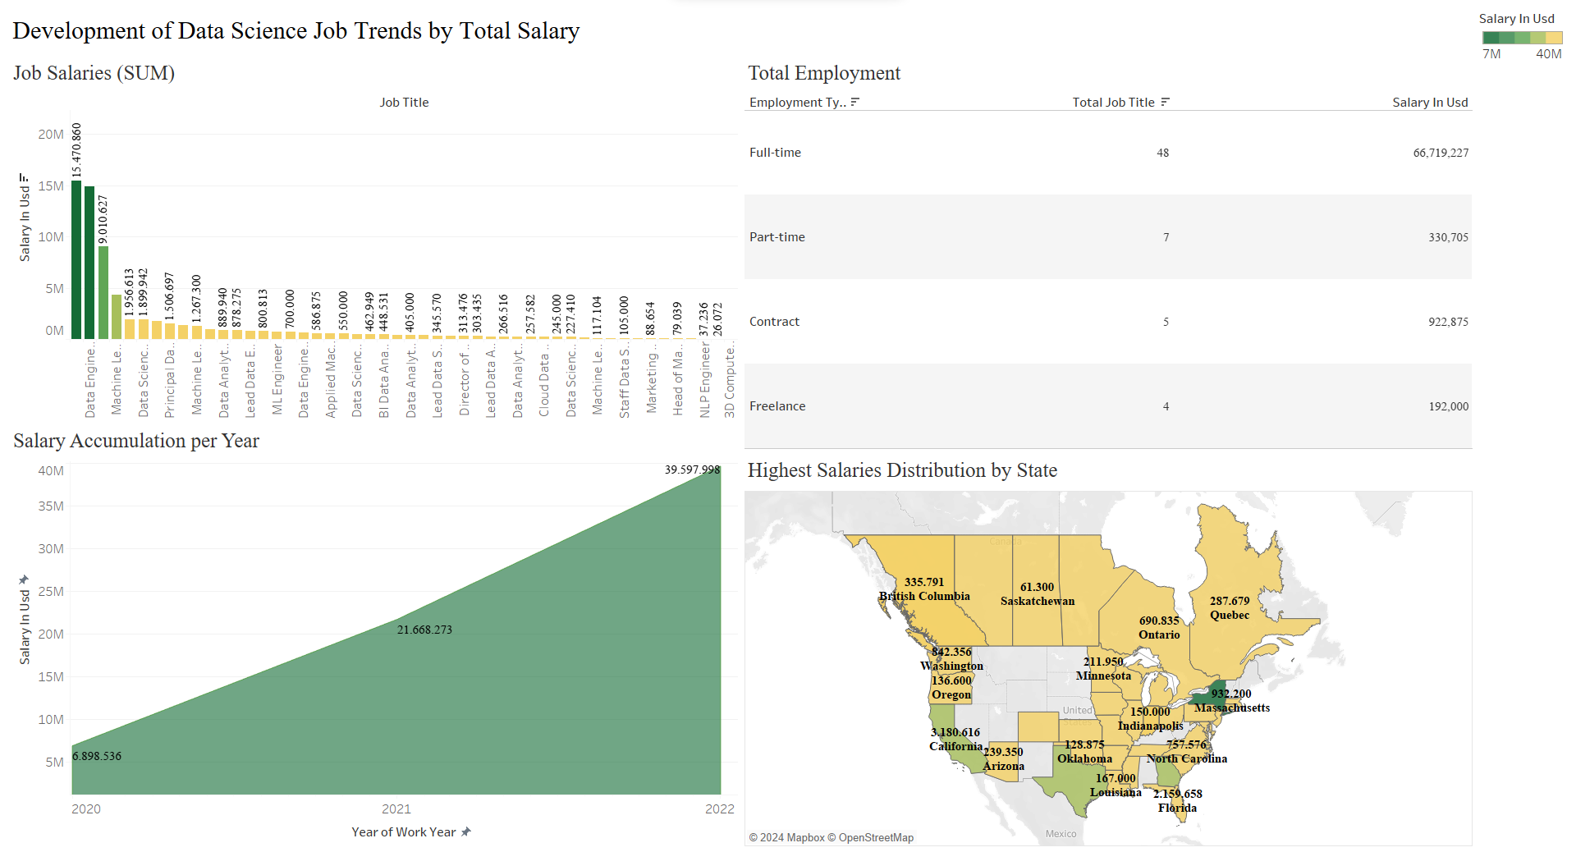

The first visualization on the dashboard illustrates the income levels for various data science jobs, sorted from highest to lowest. In this visualization, darker green shades signify higher income levels. The highest concentration of income is in Data Scientist positions, followed by Data Engineer, and other roles in descending order.

The second visualization shows the distribution of data science job types, indicated by the codes CT (Contract), FL (Freelance), FT (Full Time), and PT (Part Time), along with their accumulated salaries. According to this visualization, the Full-time category has the highest number of data science jobs, with 48 positions, followed by Part-time with 7 jobs, Contract with 5 jobs, and Freelance with 4 jobs. The table also indicates that Full-Time data science jobs are the most popular, with a total salary of 66,719,227 USD over three years.

The third visualization on the dashboard tracks the trend of increasing data science salaries year by year. It shows a significant rise from 2020 to 2021, with salaries increasing from 6,898,536 USD to 21,668,273 USD, and another rise from 2021 to 2022, with salaries increasing from 21,668,273 USD to 39,597,998 USD. This demonstrates the rapid growth in data science jobs annually, based on the yearly data science income.

The fourth visualization on the dashboard depicts the geographic distribution of salaries across different countries. This map-based visualization clearly shows the locations of these countries, with each number representing the total data science income in that country. The dashboard indicates that New York has the highest annual salary accumulation, represented by the dark green color, with a total income of 932,200 USD.

1. **Question 1: Sub-CLO-3, Weight (25%)**

Create a captivating project dashboard, incorporating views enriched with Level of Detail (LOD) calculations to unveil intricate insights and elevate data analysis.

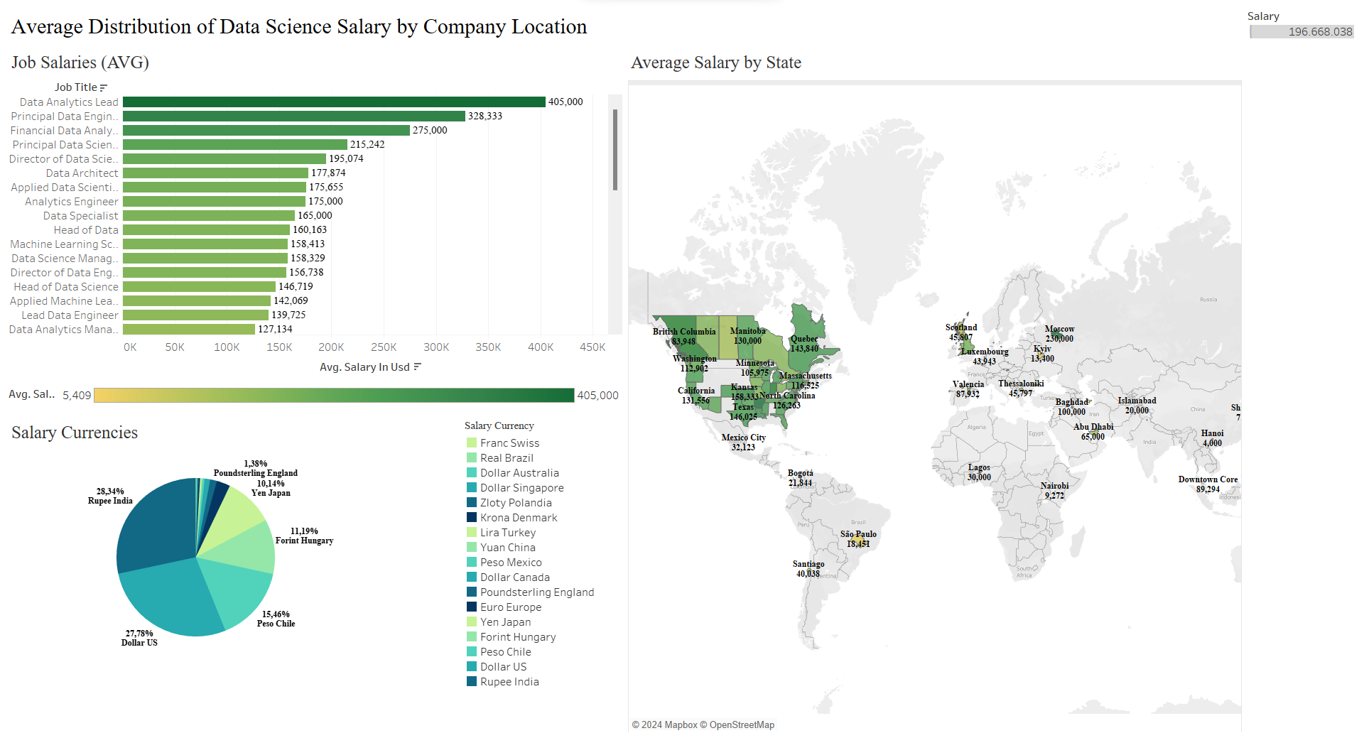

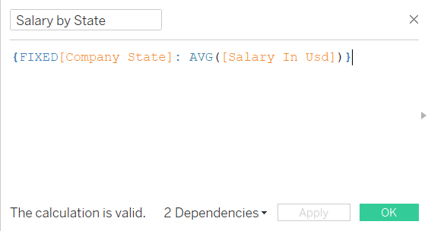

The dashboard above provides an overview of several visualizations regarding the average salary distribution for data science jobs based on company location. This dashboard contains three visualizations. The first visualization depicts the average salaries for various data science positions. From the bar chart, it can be seen that the three highest-paying jobs (in USD) are held by Data Analyst Lead with a salary of 405,000 USD, Principal Data Engineer with a salary of 328,333 USD, and Financial Data Analyst with a salary of 275,000 USD. The color in this visualization indicates that darker green represents higher data science income levels.

The second visualization uses a pie chart to analyze salaries based on currency in various countries. Since the dataset used is global, the payment of income for each data science job varies. The pie chart shows that the most common and highest percentage currency used is INR or Indian Rupee, indicating that India significantly contributes to job opportunities in the data field, followed by US Dollar, Chilean Peso, Hungarian Forint, etc.

The third visualization displays a map visualization using LOD (Level of Detail) for income per state. The LOD formula used is Fixed, using the ‘Company State’ column, and AVG, using the ‘Salary In Usd’ column. This calculation aims to produce the average salary value using USD for each state listed in the ‘Company State’ column without considering the level of aggregation. The results of this calculation are stored under the name ‘Salary by State.’ Therefore, the values shown on the map visualization are those calculated using the LOD function.

1. **Question 1: Sub-CLO-3, Weight (25%)**

Create a project dashboard featuring dynamic views integrating both Trend Lines and Forecasting techniques, ensuring predictive insights and comprehensive data visualization.

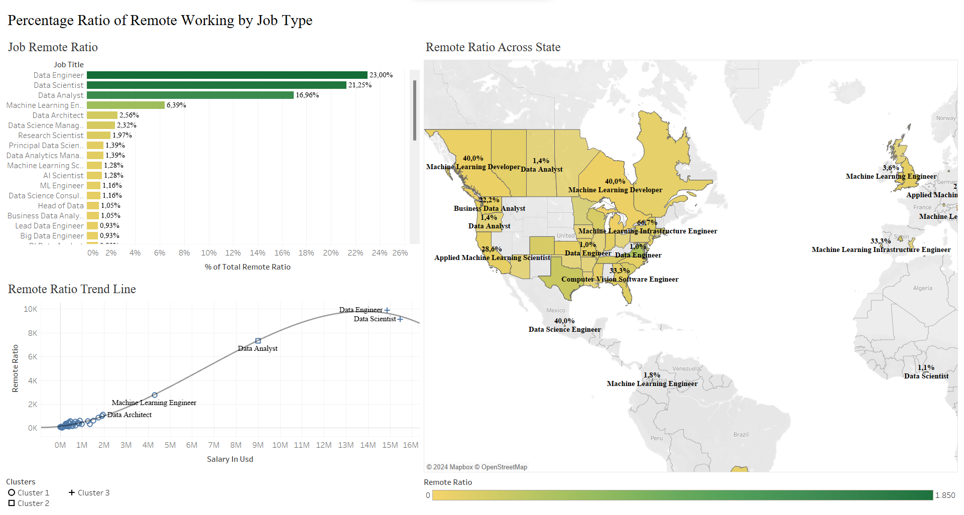

The above visualization is a dashboard that presents three visualizations: the percentage of remote jobs, a trend line of job types using clusters, and a map visualization of job distribution with the highest levels of remote work in specific states. The first visualization shows the percentage ratio of remote jobs across various job types, with darker green indicating a higher percentage of remote work. This visualization highlights that Data Engineer, Data Scientist, Data Analyst, Machine Learning Engineer, and Data Architect are the five jobs with the highest remote work ratios.

The second visualization represents the remote job ratio using a polynomial model trend line and clustering to group job types based on salary. With an R-squared value of 0.99627 and a p-value of less than 0.0001, the polynomial model is almost perfect in predicting trends. This visualization also shows three clusters: cluster 1 (round shape) represents data science job types with lower salaries, cluster 2 (square shape) indicates job types with medium salaries, represented by data analysts, and cluster 3 (plus shape) signifies high-salary job types, which include Data Engineer and Data Scientist.

The final visualization depicts the distribution of specific job types with the highest remote ratios in three states: New York (66.7%), Wales (50%), and Mexico City (40%). This map visualization also indicates that darker green colors represent higher salary levels in USD.The overall result of this dashboard is highly useful for identifying which data science jobs have the best remote work ratios along with adequate salary quality..

1. **Sub-CLO-4, Weight (25%)**

Create an article for a journal according to the provided template, and create a presentation video with a maximum duration of 10 minutes that showcases the results of the visualization project using the specified dataset. During the presentation, provide a brief overview of the created views and dashboards, as well as elucidate the narrative of the visualization. Upload the video and journal article to your OneDrive folder, then copy the link to your answer sheet.

Link:

<https://multimedianusantara-my.sharepoint.com/personal/sisteminformasi_umn_ac_id/_layouts/15/onedrive.aspx?ga=1&id=%2Fpersonal%2Fsisteminformasi%5Fumn%5Fac%5Fid%2FDocuments%2FStudent%20Project%2FIS412%20Data%20Visualization%2FA%20%2D%20Data%20Visualization%2FKelompok%208>